**3.1 Empirical Strategy**

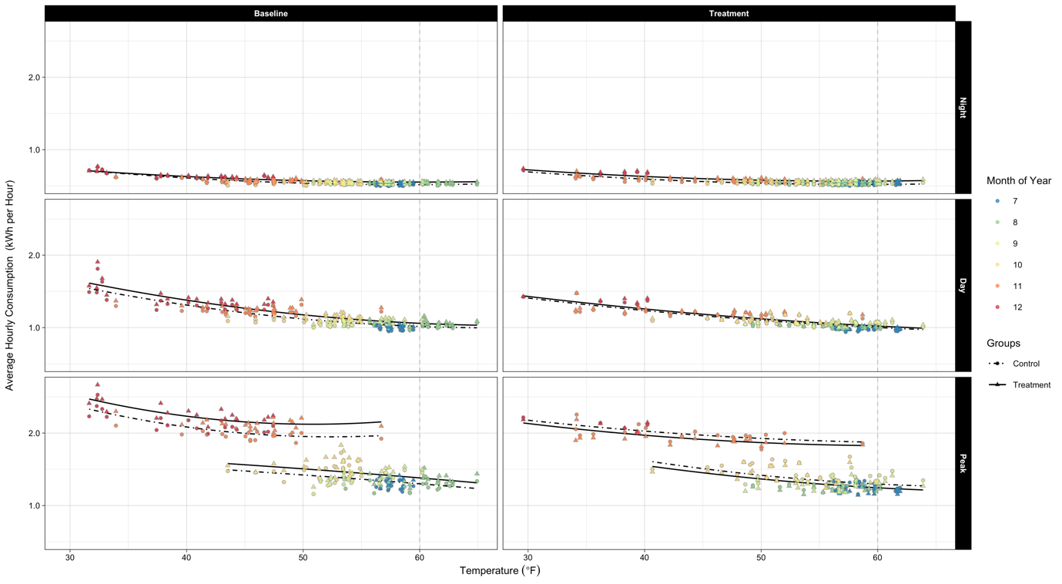

FIGURE, which shows household electricity consumption over temperature, clearly demonstrates the motivation of this research project. As illustrated in the figure, household demand for electricity grew as the temperature decreased. In other words, in addition to temperature-insensitive electricity demand (i.e., for non-temperature-control uses), there was a sizeable demand for electricity for heating (i.e., for temperature-control use) in Irish households, which is highly responsive to temperature variations. And after the introduction of the TOU prices, two significant changes in the treated households' average consumption are noticeable: first, the households assigned to the treatment group equally or less consumed electricity compared to those in the other group; second, they raised their electricity consumption level more slowly for a given temperature drop.[1] Importantly, those changes collectively imply that the impact of the deployment of the time-varying tariffs on household electricity consumption varies with temperature. In this research, I measure the temperature-dependent effect separately for temperature-control and non-temperature control uses to figure out the primary source of energy savings.

Instead of merely leaning on randomization, I employ a difference-in-differences (DID) strategy to estimate the dynamic-price-inducing electricity savings, as the previous studies exploiting the same dataset did.[2] In those papers, fixed-effects (FEs) allow the identification strategy to be implemented. Specifically, in their main specification, Pon (2017) included household and month-by-year FEs, while Prest (2020) incorporated household-by-half-hour-period and week-of-sample FEs. Since those papers focused on measuring how households, on average, respond to the TOU price regimes newly introduced, adding such FEs to their models in order to use a panel DID framework serves their research purpose. On the other hand, one of the main interests of this research is to estimate the impacts of shifting to TOU tariffs on household electricity demand conditional on average daily HDDs for two distinct channels of energy savings. To be specific, I estimate the average treatment effects (ATEs) of the dynamic prices on household electricity demand by exploiting the within-household electricity consumption changes across not only periods but temperatures.[3] Therefore, more flexible controls rather than FEs, not sweeping out temperature variations across days, are required in my empirical analysis. For that reason, the typical DID specification that includes three indicator variables is utilized in the following analysis.[4]

Two meaningful features also stand out from the figure. First, the minimum household electricity consumption occurs around 60F. This phenomenon supports the setting of the reference temperature for calculating daily HDDs at the very level. Second, participating households' electricity demand at a given temperature significantly varies within a day. Obviously, during the peak period, their electricity consumption is not only maximum but also most sensitive to temperature variations, suggesting that the peak period should be the primary interest in the following empirical analysis for examining the impacts of the deployment of the TOU prices. In addition, the seasonality in electricity consumption is apparent during peak hours. Naturally, household demand for electricity during peak hours in the winter season is markedly higher than in the summer season. Moreover, an interesting observation is that the two seasons show different average consumption levels for a given temperature. This observation suggests a strong serial correlation of electricity consumption.

**3.2 (…)**

(…)

1. The latter point is recognized from the flattened lines in the right panels of FIGURE, especially in days with low temperatures.
2. The CER experiment dataset primarily utilized in my empirical analysis was generated from a carefully developed randomized controlled trial (RCT). Because random assignment of participating households puts selection bias right, observed differences in electricity consumption between the control and treatment groups after introducing the TOU tariffs are only attributable to their differences in exposure to the time-varying electricity prices. Despite the advantage secured from a well-designed randomized experiment, participating households' meter reads in the dataset are still not free from a possible threat to identifying the impact of the TOU prices on household demand for electricity: non-trivial differences in electricity demand between the baseline and treatment periods. As illustrated in FIGURE, even the control group shows conspicuous differences in the average hourly electricity consumption between the two periods across hours of the day. Therefore, we cannot simply rule out the possibility that a time trend reflecting underlying changes in energy consumption, but not being correlated with the treatment status, existed during the experiment period. In other words, a naive comparison between the control and treatment groups without accounting for the likely time trend can introduce some bias in the estimation of the effect.
3. The attrition rate during the RCT was about 20%. The main reasons for participant attrition were changes in tenancy and supplier. Due to the imperfect compliance, the estimates must be interpreted as local average treatment effects (LATEs). However, according to CER (2011), attrition was unlikely to be associated with the RCT. Furthermore, the level of attrition varied only marginally across treatment status.
4. Under three identifying assumptions, applying the DID strategy to measure energy savings obtained from adopting the TOU prices makes sense. First, the parallel trend assumption is required for the DID estimator. Considering that the 30-minute interval meter reads for participating households were collected from a trial, the assumption means that the pre-treatment-period load profile for the treated households should be very similar to that for the non-treated households. FIGURE A showing average within-day load profiles for the two groups during the baseline period supports the plausibility of the parallel trend assumption. In addition, the electricity consumption profile for the control group illustrated in FIGURE B, which smoothly evolved over the entire experiment period although heavily fluctuated day to day, suggests its high reliability as a counterfactual under the assumption.

   The second identifying assumption necessary for the plausibility of the identification strategy employed is the assumption of common temporal shocks. This assumption implies that a treatment-status-irrelevant unexpected event occurring at the same time as or following the deployment of the dynamic prices should have the same impact on both the control and treatment groups. Although the common shocks assumption cannot be tested directly, the similar trends in electricity demand profiles for the control and treatment groups shown in FIGURE B support the assumption required for the DID approach.

   Third, the stable unit treatment value assumption (SUTVA) must hold too. The SUTVA requires that introducing TOU prices did not affect the electricity consumption of the untreated households. That is, the SUTVA allows no spillovers. During the recruitment process, the locational distribution of the participating households was aligned with that of the total Irish population to construct a representative sample of the national population. Because only a few thousand households scattered geospatially participated in the nationwide experiment, it is unlikely that the treated households influenced the households allocated to the control group. This again supports the SUTVA required under the DID identification strategy.